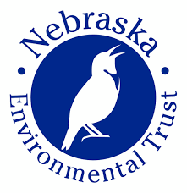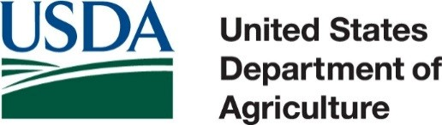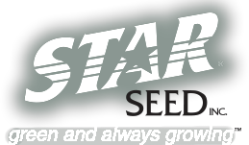Soil Health Field Day

e

Soil Health Workshop focused on using diverse rotations to achieve maximum soil health

August 25

Hitchcock County Fairgrounds
Culbertson, Nebraska

8:00-8:30 – Registration

8:30-9:30 – Rainfall Simulator – Candy Thomas, NRCS

9:30-12:00 – Field Tour, Soil Pit, Grazing Tools

12:00 – Lunch at Fairgrounds

1:00-1:30 – Grazing Forages – John and Jake Miller

1:30-2:15 – Cover Crop Management and Uses – Michael Thompson

2:15 – Increased Soil Function Decreases Dependency on
Chemical Inputs – Ray Archuleta, NRCS

RSVP by August 18 to 308-350-0034 or lazyjmranch@gmail.com

Sponsors:

Middle Republican Natural Resource District

Natural Resources Conservation Service

